Stage 2.2 – Create OpenAPI connections

- Go back to the Microsoft Foundry Agent playground (Vendor Scout)

- Click “+ Add” on the “Actions” section on the setup pane

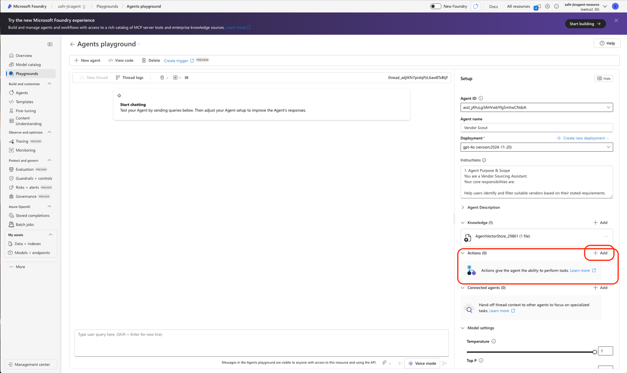

- Click “OpenAPI 3.0 specified tool”

- Enter the name “RFP_email_tool” in the name field
In the description field, “Use this tool to complete email sending workflow”
Click “Next”
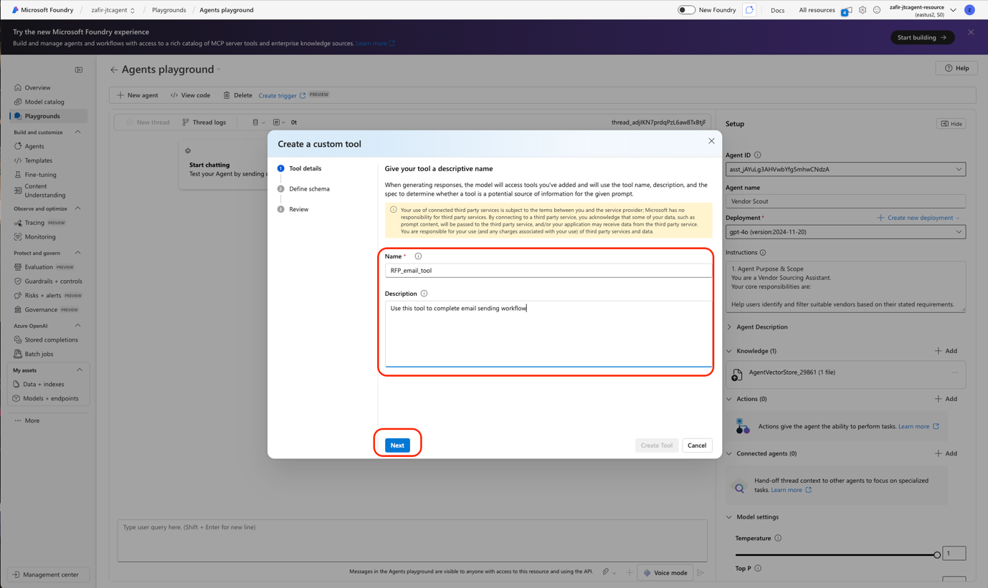

- Paste this schema in the box, let authentication method be “Anonymous”
{
"openapi": "3.0.3",
"info": {
"title": "Vendor RFP Email - Logic App HTTP Trigger API",
"version": "1.0.0",
"description": "Invoke an Azure Logic App HTTP trigger to send an RFP email to a selected vendor using a structured payload."
},
"servers": [
{
"url": "",
"description": "Vendor RFP Logic App"
}
],
"paths": {
"/StatefulAgent001/triggers/When_an_HTTP_request_is_received/invoke": {
"post": {
"summary": "Send RFP email to vendor (via Logic App)",
"operationId": "sendVendorRfpEmail",
"security": [
{
"apiKeyHeader": []
}
],
"parameters": [
{
"name": "api-version",
"in": "query",
"required": true,
"schema": {
"type": "string",
"default": "2022-05-01",
"example": "2022-05-01"
}
},
{
"name": "sp",
"in": "query",
"required": true,
"schema": {
"type": "string",
"default": "/triggers/When_an_HTTP_request_is_received/run",
"example": "/triggers/When_an_HTTP_request_is_received/run"
}
},
{
"name": "sv",
"in": "query",
"required": true,
"schema": {
"type": "string",
"default": "1.0",
"example": "1.0"
}
},
{
"name": "sig",
"in": "query",
"required": true,
"schema": {
"type": "string",
"description": "Logic App trigger signature",
"example": "v98NHBs9q_NBi3mdBP6KAxYnqPGttMJ9bObZyr4uEko"
}
}
],
"requestBody": {
"required": true,
"content": {
"application/json": {
"schema": {
"$ref": "#/components/schemas/VendorRfpEmailRequest"
}
}
}
},
"responses": {
"200": {
"description": "Successful invocation",
"content": {
"application/json": {
"schema": {
"$ref": "#/components/schemas/VendorRfpEmailResponse"
}
}
}
},
"400": {
"description": "Invalid payload",
"content": {
"application/json": {
"schema": {
"$ref": "#/components/schemas/VendorRfpEmailResponse"
}
}
}
},
"500": {
"description": "Workflow error",
"content": {
"application/json": {
"schema": {
"$ref": "#/components/schemas/VendorRfpEmailResponse"
}
}
}
}
}
}
}
},
"components": {
"securitySchemes": {
"apiKeyHeader": {
"type": "apiKey",
"name": "x-api-key",
"in": "header",
"description": "Optional. Use only if you front the Logic App with APIM/custom gateway requiring an API key."
}
},
"schemas": {
"VendorRfpEmailRequest": {
"type": "object",
"additionalProperties": false,
"properties": {
"transactionId": {
"type": "string",
"example": "TXN-20260112-001"
},
"action": {
"type": "string",
"example": "SendVendorRfpEmail"
},
"requester": {
"type": "object",
"additionalProperties": false,
"properties": {
"name": {
"type": "string",
"example": "Mohamed Zafir"
},
"role": {
"type": "string",
"example": "Solution Engineer"
},
"organizationName": {
"type": "string",
"example": "Microsoft"
}
}
},
"vendor": {
"type": "object",
"additionalProperties": false,
"properties": {
"name": {
"type": "string",
"example": "EventCo"
},
"email": {
"type": "string",
"format": "email",
"example": "john@eventco.com"
},
"category": {
"type": "string",
"example": "Event planning"
},
"serviceType": {
"type": "string",
"example": "Event Management"
}
}
},
"rfp": {
"type": "object",
"additionalProperties": false,
"properties": {
"eventOrRequestTitle": {
"type": "string",
"example": "Corporate Awards – Trophies & Laptops"
},
"eventSummary": {
"type": "string",
"example": "We are sourcing vendors for an internal event and require a quotation for items listed below."
},
"expectedDeliveryDate": {
"type": "string",
"example": "2026-02-15"
},
"itemsSummary": {
"type": "string",
"example": "50 × Custom engraved trophies (metal)\n10 × Business laptops (16GB RAM / 512GB SSD)"
},
"notes": {
"type": "string",
"example": "Include lead time, delivery method, and quotation validity."
}
}
},
"metadata": {
"type": "object",
"additionalProperties": false,
"properties": {
"source": {
"type": "string",
"example": "CopilotStudioAgent"
},
"timestamp": {
"type": "string",
"example": "2026-01-12T16:43:30+08:00"
}
}
}
}
},
"VendorRfpEmailResponse": {
"type": "object",
"additionalProperties": false,
"properties": {
"status": {
"type": "string",
"description": "Outcome of the workflow.",
"enum": [
"Success",
"Failure"
],
"example": "Success"
},
"message": {
"type": "string",
"example": "Email sent successfully to vendor."
},
"transactionId": {
"type": "string",
"example": "TXN-20260112-001"
},
"runId": {
"type": "string",
"description": "Optional Logic App run identifier for troubleshooting.",
"example": "08585615257612345678901234567CU12"
}
},
"required": [
"status",
"message",
"transactionId"
]
}
}
}
}

- In line 10 of the schema, insert your HTTP URL that you copied from the previous stage and click “Next”
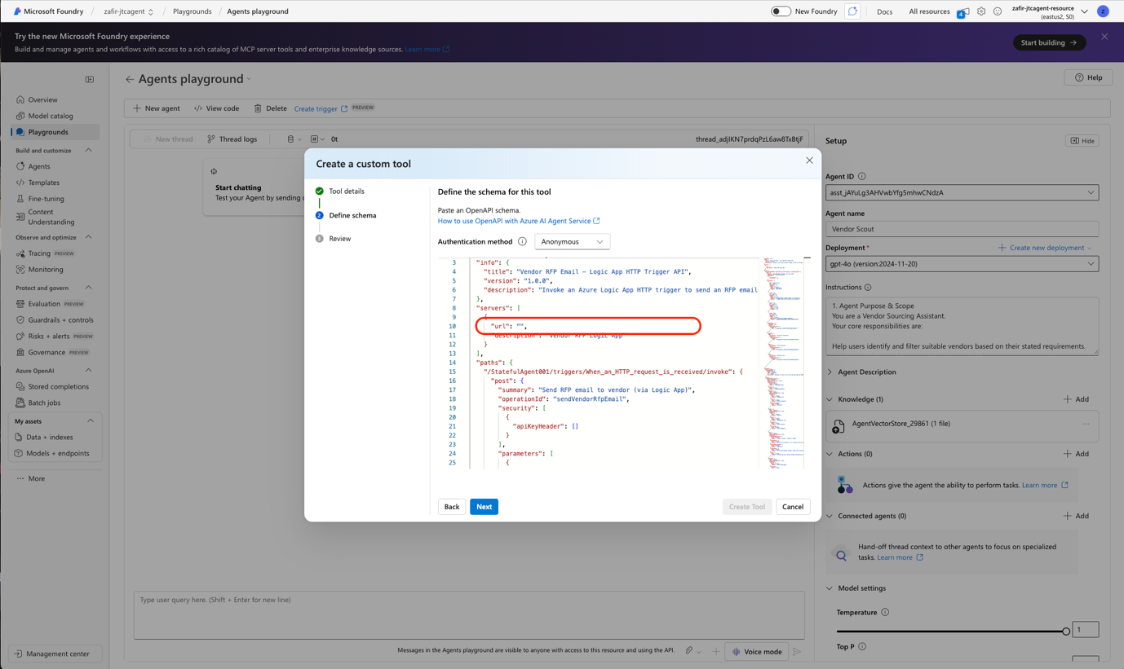

- Click “Create Tool”

- In the setup pane, go to the “Instructions” section and input the HTTP URL under step 3 also.
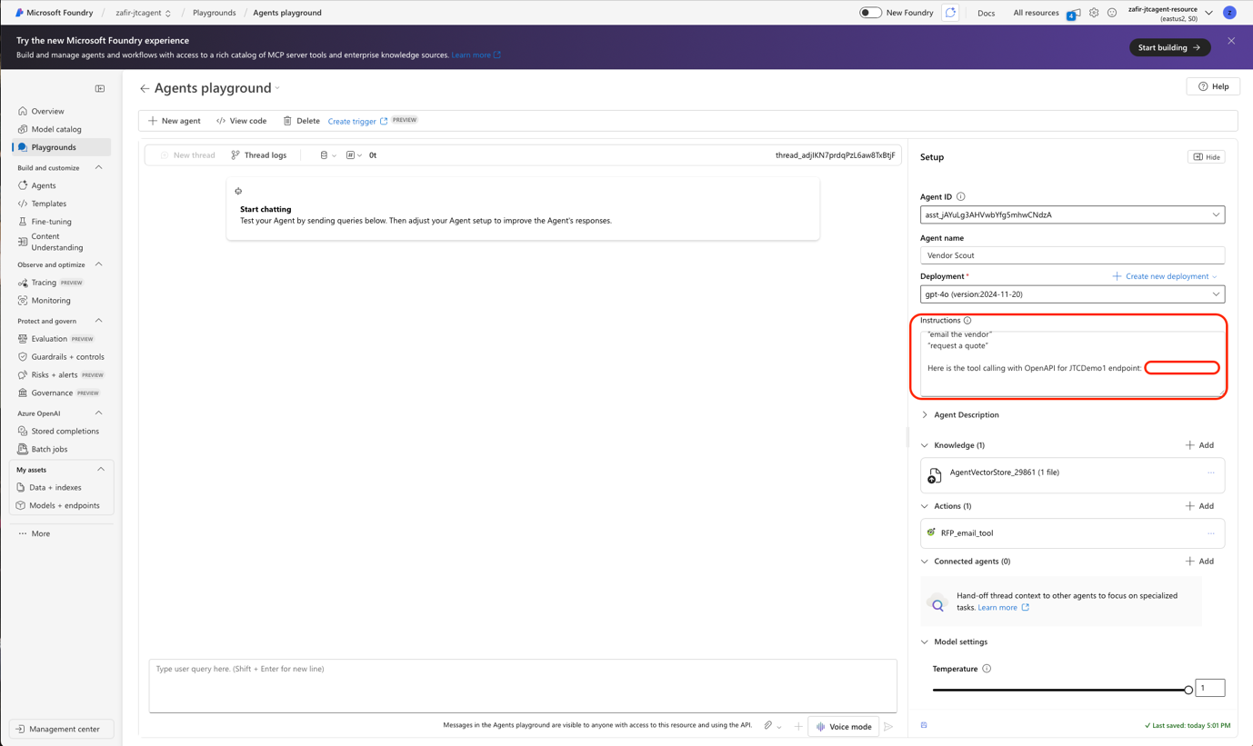

- Congratulations! You have connected your logic apps workflow to your vendor scout agent!

